**Diode**

What is a diode?

* Diode is the component that can control the flow of current in one direction.
* Two types of diodes.

1)Semiconductor diode. (Made up of silicon)

2)Ziner diode. (Made up of glass)

* It is measured in mA to A. (milliampere to ampere)
* Main important use of diode is AC to DC. (Rectifier)
* It is also used in other devices. (Mobile phones, power supplies, and electronic devices)
* It has two terminals:

1. 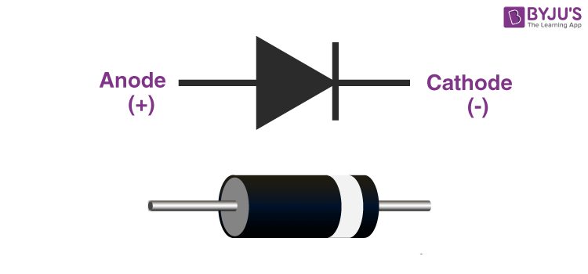Anode (+)
2. Cathode (-)

* We can use a diode in two ways.

1. Forward Bias
2. Reverse Bias

**P-N Junction Diode**

When a p-type semiconductor is joined with an n-type semiconductor, the arrangement so formed is known as P-N Junction Diode.

* P-type has the majority of holes and the minority of electrons.
* N-type has the majority of electrons and the minority of holes.
* P-type and N-type are normally neutral.
* When the p-type is joined with the n-type the electron moves from the n-type to the p-type then a negative charge is created in the p-type, and holes move to the n-type due to the shorter of the electrons’ positive charge created in the n-type and this process is known as diffusion.
* In this way, diffusion of electrons and holes from the n-side and p-side starts this diffusion is take place till a layer is formed which is called the depletion layer.
* When the depletion layer is formed, the new electron can’t move to p-type because the electrons present in the depletion layer can repel the electrons which move from n-type to p-type same as for holes.
* It can form a barrier between p-type and n-type and create a potential known as a potential barrier.
* Crossing the electron from n-type to p-type and holes from p-type to n-type we require a definite potential. Which is equal to or greater than the potential barrier then the electron and holes move easily without repealing of electron and holes present in the depletion layer.

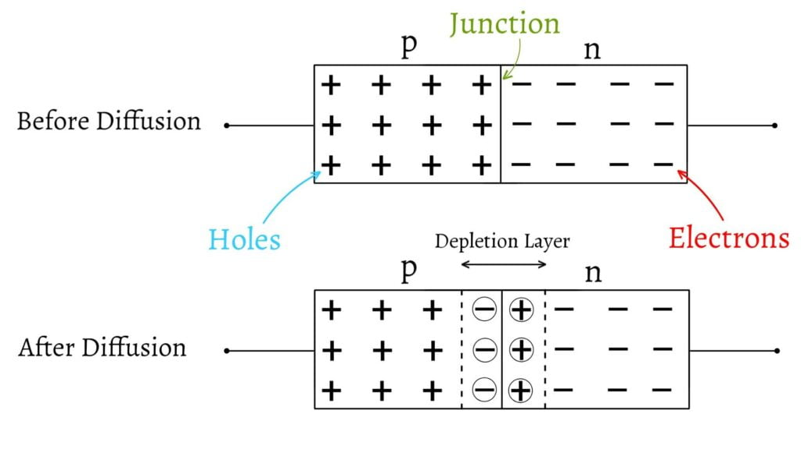

**Application Of Diode**

1. **Rectifier: -** Rectifier is a circuit that is used to convert an AC signal into pulsating DC signal.

* Diode plays a vital role in the rectifier.
* Diode is commonly used in the rectifier to convert an AC to DC.
* This is achieved by using one or more diodes to block the negative half of the AC cycle, allowing only the positive half to pass through.

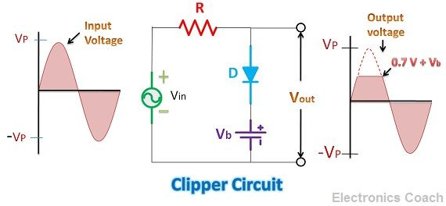

1. **Clipper: -** A clipper is an electronic circuit used to limit or “clip” waveform amplitude above or below a certain level. The clipped waveform will have a flattened peak or through at the clipping level.

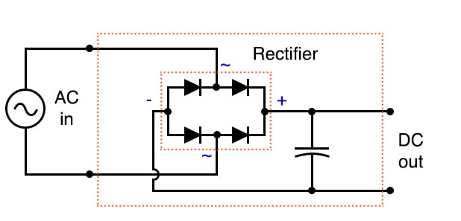

1. **Clamper: -** It is a circuit that clamps the input signal to the +ve or -ve side of a signal without changing the shape of the signal.

* 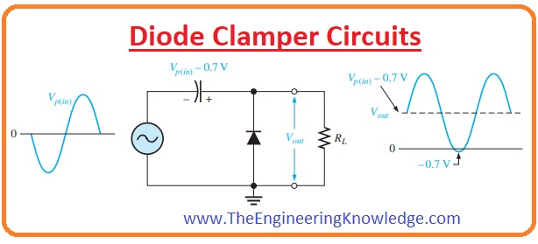In this circuit we use a capacitor with a diode.

1. **Protection: -** Diode can be used for protection against voltage surges, spikes, and electrostatic discharge. They can limit the amount of voltage or current that passes through a circuit to protect sensitive components from damage.
2. **Logic Gates: -** Diodes are used in the construction of logic gates, which are the building blocks of digital electronics. They can use to implement Boolean logic functions such as AND, OR, and NOT.

**V-I characteristics of P-N junction diode**

A diode's V-I (voltage-current) characteristics are a graph showing the relationship between the voltage across the diode and the current through it.

**Case 1: -** when the applied volt is positive and has V-I characteristics we will get the vertical line.

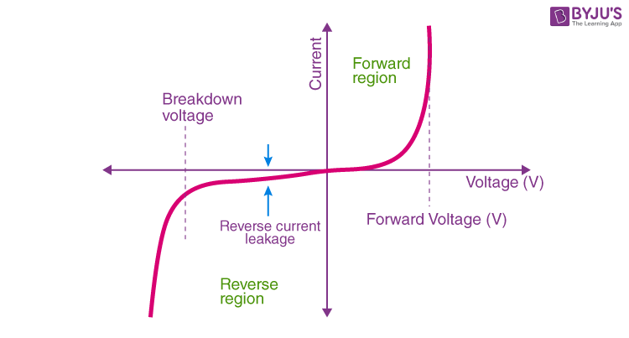**Case 2: -** When the applied volt is negative and for that case, we will get the horizontal line in the negative x direction.

* we can understand that there are three regions in which the diode works, and they are:

1)Forward Bias

2) Reverse Bias

3) Zero Bias

**Types of Diode**

1. **PN Junction Diode**

The normal type of diode.

Used in RF (radio frequency) or other low-current applications.

1. **Zener Diode**

Used to provide a stable reference voltage.

Worked under reverse bias conditions and found that when a particular voltage is reached it breaks down.

Used to offer a reference voltage in power supplies.

1. **Schottky Diode**

Used in rectifier application, clamping diode, and also in RF application.

Diode has a lower forward voltage drop than ordinary silicon PN junction diodes.

1. **Gunn Diode: -**

Used for producing microwave oven signals.

A semiconductor device that has two terminals.

1. **Laser Diode:** -

used in many applications like DVDs, CD drives, and laser light pointers.

1. **Light Emitting Diode: -**

In forwarding bias, then the current flows through the junction and generates the light.

1. **Photodiode: -**

Used to detect light-photodiodes operating under reverse bias conditions.

1. **Pin Diode: -**

It has standard P-type and N-type areas used for switching and other application.

1. **Step Recovery Diode: -**

A type of microwave diode is used to generate a pulse at very HF (high frequency).

**Operation Of P-N Junction Diode**

* **Potential Barrier: -**

The significance of this built-in potential across the junction is that it opposes both the flow of holes and electrons across the junction, which is why it is called a potential barrier. The resulting electronic device that has been made is commonly called a PN junction diode or simply a signal diode.

* **Knee Voltage: -**

It is the forward voltage at which the current through the junction starts to increase rapidly.

It may be added here that to get useful current through a p-n junction, the applied voltage must be more than the knee voltage.

* **Reverse Leakage: -** (current in reverse current)

Reverse leakage in a PN junction diode refers to the small current that flows through the diode in the reverse bias direction when a reverse voltage is applied across the diode. In an ideal diode, no current should flow in the reverse bias direction, but in reality, there is always some amount of reverse leakage current.

* **Breakdown voltage: -**

The breakdown voltage in a PN junction diode is the voltage at which the diode starts conducting in the reverse-biased direction, beyond a certain level of reverse voltage. When the reverse voltage applied to a diode exceeds its breakdown voltage, the diode breaks down, and a large number of current starts flowing through it.